Assignment -3

%%Logarithmic transformation
a=imread('pout.tif');
subplot(1,2,1);
imshow(a);
b=im2double(a);
[m,n]=size(a);
for i=1:m-1
for j=1:n-1
r=b(i,j);
c(i,j)=log(1+r);
end;
end;
subplot(1,2,2);
imshow(c);

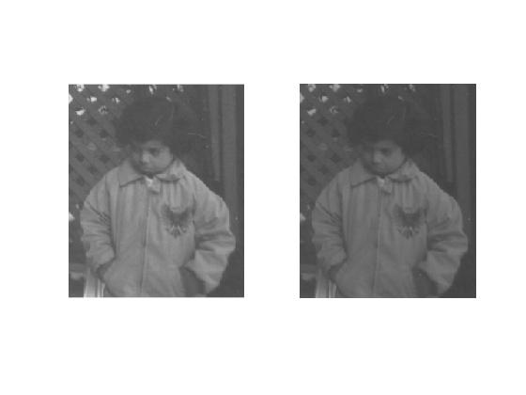

Negative Transformation:
a=imread('pout.tif');
subplot(1,2,1);
imshow(a);
title('Original Image');
[m,n]=size(a);
for i=1:m-1
for j=1:n-1
s(i,j)=256-1-a(i,j);
end;
end;
subplot(1,2,2);
imshow(s);
title('Negative Image');
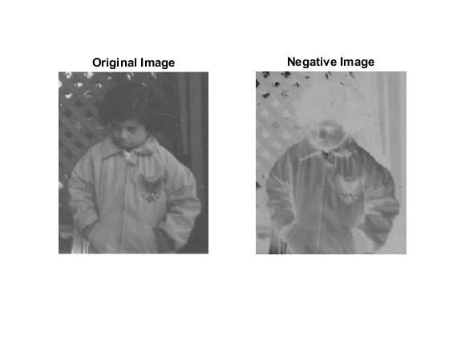
Power law transformation
clear all;
a=imread('tire.tif');
subplot(1,2,1);
imshow(a);
b=im2double(a);
[m,n]=size(a);
for i=1:m-1
for j=1:n-1
s(i,j)=a(i,j)^2;
end;
end;
subplot(1,2,2);
imshow(s);

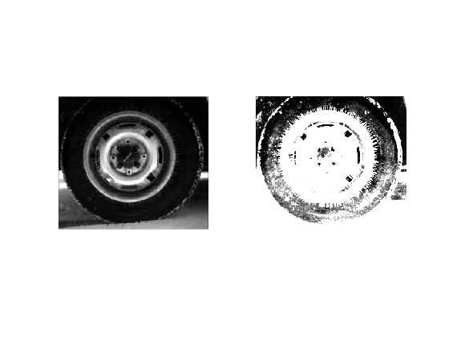
Contrast stretching

%clear all;
a=imread('pout.tif');

subplot(1,2,1);
imshow(a);
b=im2double(a);
[m,n]=size(a);
for i=1:m-1
for j=1:n-1
r=b(i,j);
if find(0<r & r<100)
s(i,j)=r/2;
elseif find(r>=100 & r<150)
s(i,j)=1.5*r;
else find(r>=150)
s(i,j)=0.5*r;
end;
end;
end;
subplot(1,2,2);
imshow(s);

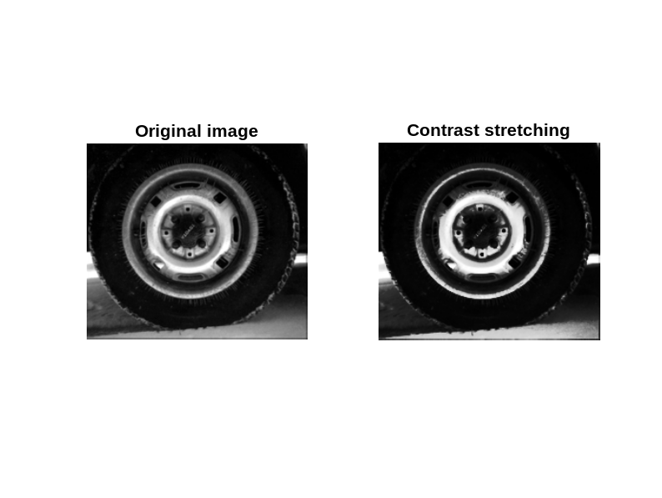

%%%biTPLANE SLICING
i=imread('pout.tif');
a=bitget(i,1);
figure,
subplot(2,2,1);imshow(logical(a));title('Bit plane 1');

a=bitget(i,2);
subplot(2,2,2);imshow(logical(a));title('Bit plane 2');

a=bitget(i,3);
subplot(2,2,3);imshow(logical(a));title('Bit plane 3');

a=bitget(i,4);
subplot(2,2,4);imshow(logical(a));title('Bit plane 4');

a=bitget(i,5);
figure,
subplot(2,2,1);imshow(logical(a));title('Bit plane 5');

a=bitget(i,6);
subplot(2,2,2);imshow(logical(a));title('Bit plane 6');

a=bitget(i,7);
subplot(2,2,3);imshow(logical(a));title('Bit plane 7');

a=bitget(i,8);
subplot(2,2,4);imshow(logical(a));title('Bit plane 8');

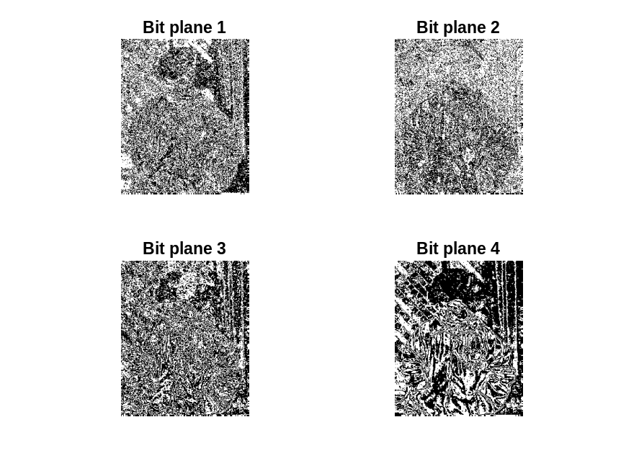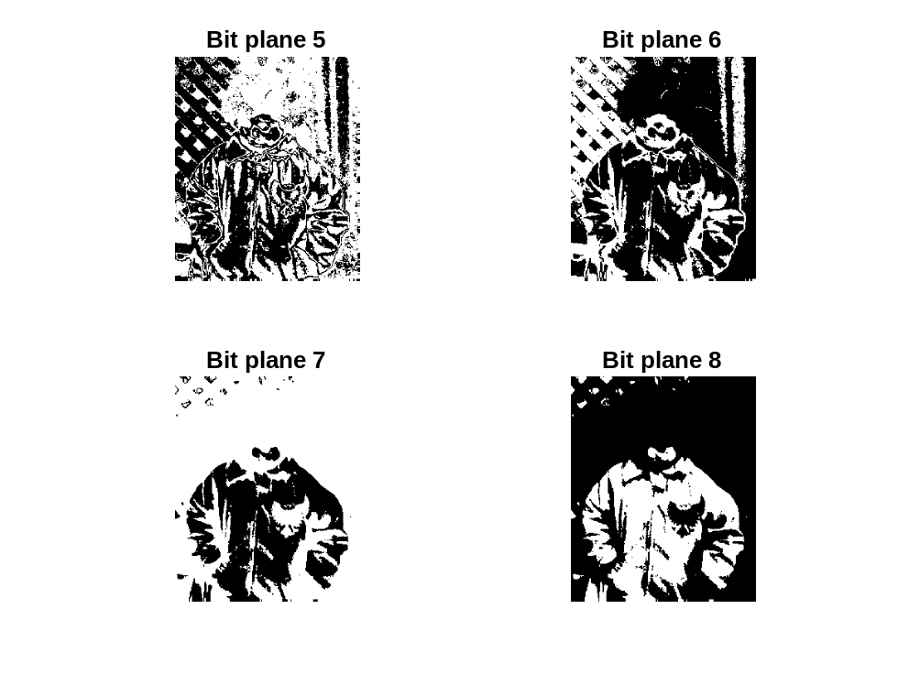

%%%HISTOGRAM EQUALISATION

clear all;
clc;
close all;
a=imread('pout.tif');
b=zeros(1,256);
[r,c]=size(a);

for x=1:1:r
for y=1:1:c
if a(x,y)<1
continue;
else
t=a(x,y);
end
b(t)=b(t)+1;
end
end

subplot(1,2,1);
imshow(uint8(a));
title('Original Image');

subplot(1,2,2);
bar(b);
title('Histogram of image');

numofPixels = size(a,1) * size(a,2);
H = uint8(zeros(size(a,1),size(a,2)));
freq = zeros(256,1);
probf = zeros(256,1);
probc = zeros(256,1);
cum = zeros(256,1);
output = zeros(256,1);

for i = 1:size(a,1)
for j = 1:size(a,2)
value = a(i,j);
freq(value+1) = freq(value+1) + 1;
probf(value+1) = freq(value+1)/numofPixels;
end
end

sum = 0;
noofBins = 255;
for i=1:size(probf)

sum=sum+freq(i);

cum(i)=sum;

probc(i)=cum(i)/numofPixels;

output(i)=round(probc(i)*noofBins);

end

for i=1:size(a,1)

for j=1:size(a,2)

H(i,j)=output(a(i,j)+1);

end

end
figure,
subplot(2,1,1);
imshow(H);
title('Image after Histogram Equalization');

subplot(2,1,2);
imshow(histeq(a));
title('Image using HistEq');
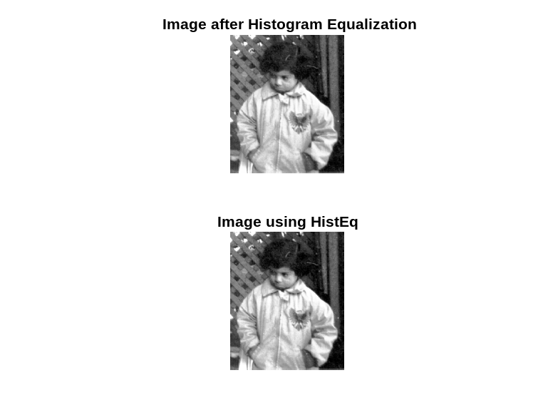
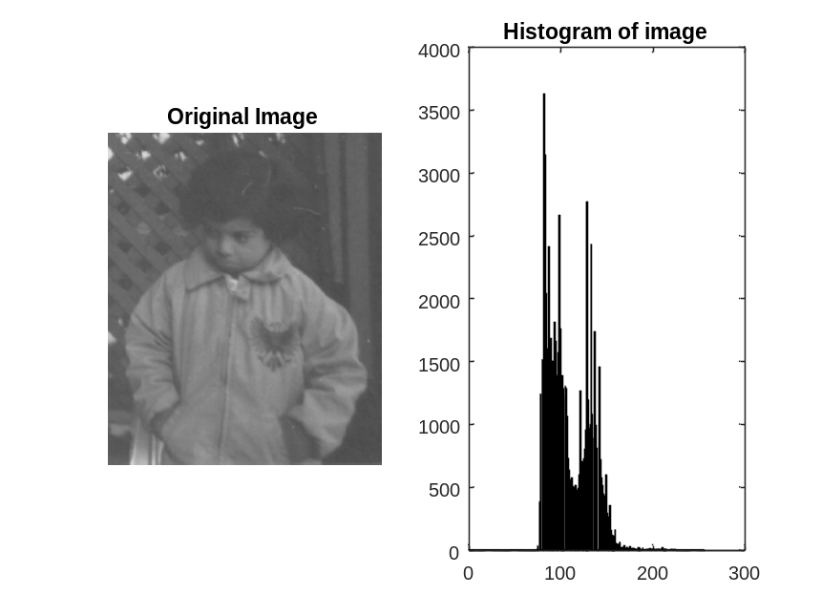
SALT AND PEPPER

clc;
clear all;
close all;
A = imread('eight.tif');
A = imshow(imnoise(A,'salt & pepper',0.28));
figure,imshow(A);
title('Salt and Pepper Image');

modifyA=zeros(size(A)+2);
B=zeros(size(A));

for x=1:size(A,1)
for y=1:size(A,2)
modifyA(x+1,y+1)=A(x,y);
end
end

for i= 1:size(modifyA,1)-2
for j=1:size(modifyA,2)-2
window=zeros(9,1);
inc=1;
for x=1:3
for y=1:3
window(inc)=modifyA(i+x-1,j+y-1);
inc=inc+1;
end
end

med=sort(window);
B(i,j)=med(5);

end
end
B=uint8(B);
title('IMAGE AFTER MEDIAN FILTERING');
figure,imshow(B);

